CREATE OR REPLACE PACKAGE employee_pkg AS

PROCEDURE update_salary(

p_emp_id IN EMPLO.EMPID%TYPE,

p_emp_salary IN EMPLO.netSAL%TYPE

);

END employee_pkg;

/

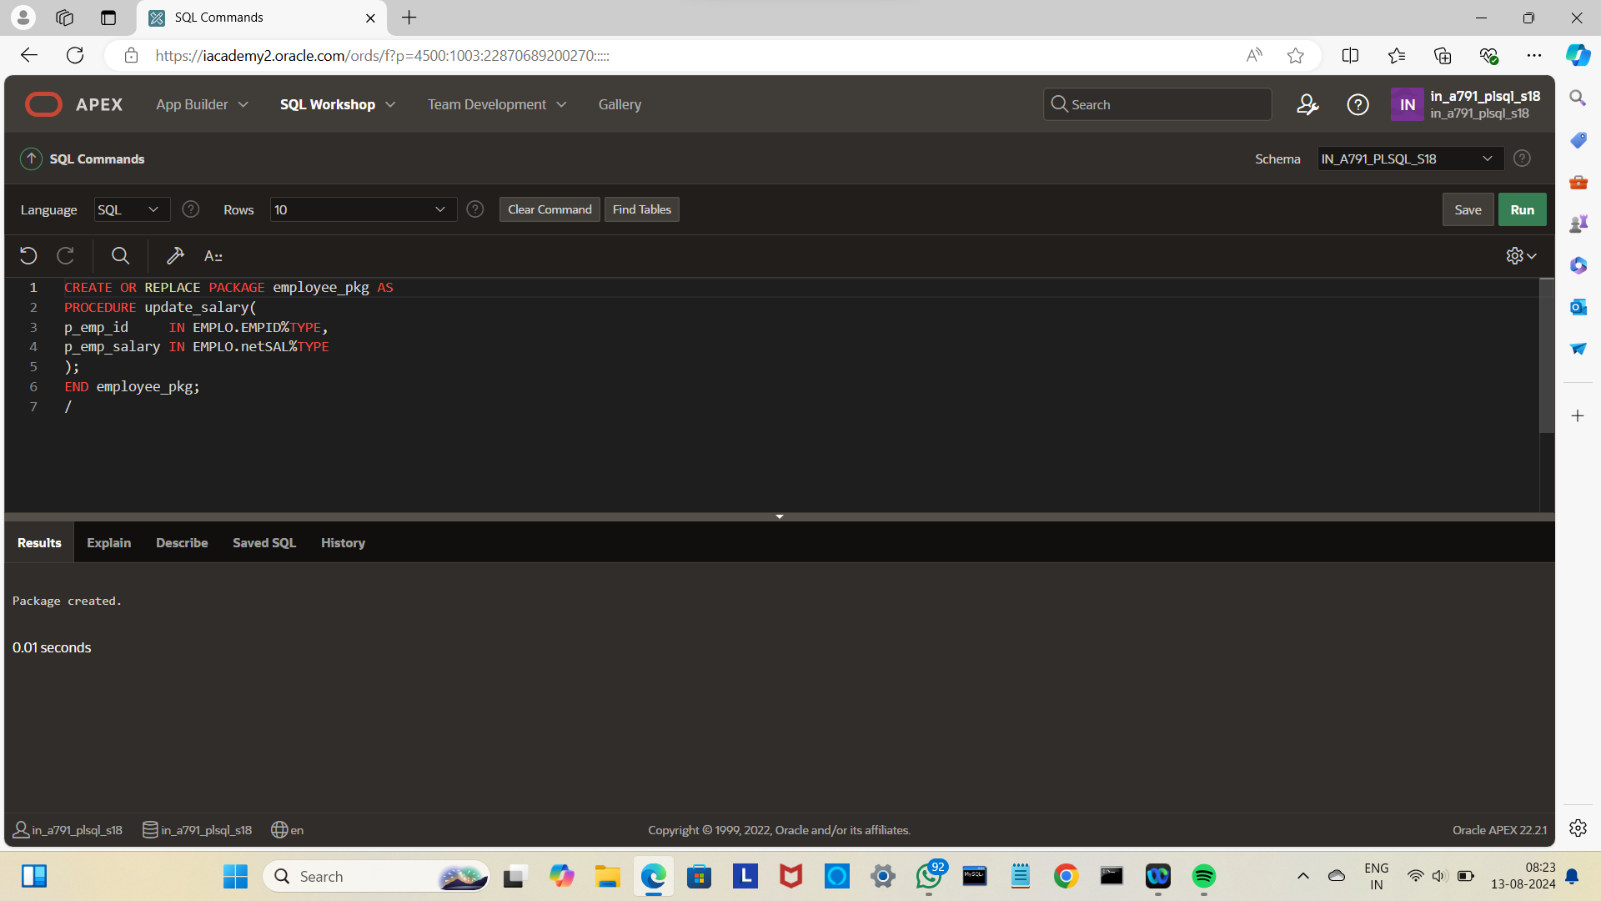

CREATE OR REPLACE PACKAGE BODY employee_pkg AS

PROCEDURE update_salary(

p_emp_id IN EMPLO.EMPID%TYPE,

p_emp_salary IN EMPLO.NETSAL%TYPE

) IS

BEGIN

UPDATE EMPLO

SET NETSAL = p_emp_salary

WHERE EMPID = p_emp_id;

END update_salary;

END employee_pkg;

/

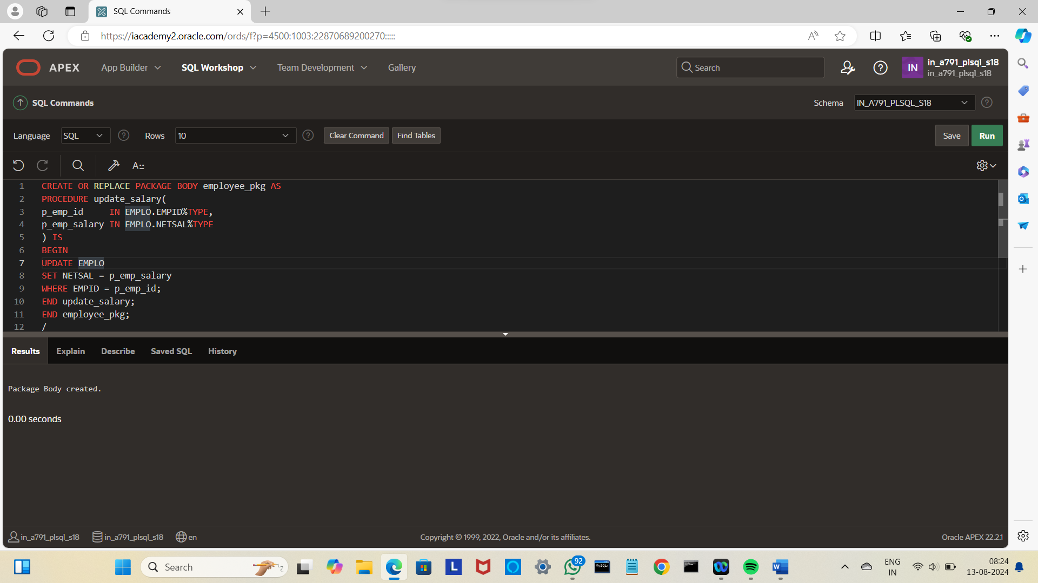

BEGIN

EMPLOYEE_PKG.UPDATE_SALARY(103,200000);

END;

/

